Contents

1. Annual Audit Planning (AAP) information 1
2. ExAnte Assurance Heatmap 3
3. Organisational 3
4. Audit Object L2 actualization 6
5. Process based information 7
5.1. Vestima (Order Routing and Execution, Transfers) 11
5.2. VestimaPRIME (order routing and execution, transfers) 14
5.3. Fund acceptance and data management 17
5.4. Customer services 20

Annual Audit Planning (AAP) information
In 2023, an audit titled 2023-036 IFS Operations (CBL, CBF, CFCL) was conducted, covering the entities CBL, CS, CBF, LuxCSD, and CFCL and the period from 1 April 2021 until 31 March 2023.

The following audit objects were previously included and remain within the current scope:
- AU-025-01 – Order routing and execution
- AU-025-02 – Transfers
- AU-025-03 – Fund acceptance and data management
- AU-025-04 – Customer services and onboarding activities of participants set up
- AU-025-07 – Vestima (order routing and execution, transfers)
- AU-025-08 – Vestima PRIME (order routing and execution, transfers)

Also, the below were considered for this audit, albeit with a limited focus on the oversight of services provided by the respective legal entities.
- AU-057-27 – IFS – last covered in 2023-018 audit.
- AU-082-03 – CFCL CAL Growth business (operations) – last covered in 2024-039 audit.
- AU-019-01 – Settlement – last covered in 2024-012 audit.
- AU-019-03 – non-STP instructions – last covered in 2024-012 audit.
- AU-019-05 – Global Bearer Certificates Settlement – last covered in 2024-012 audit.
- AU-019-06 – Position Management – last covered in 2024-012 audit.
- AU-019-07 – Registered Shares – last covered in 2024-012 audit.
- AU-020-01 – NCSC-NCCIP cash instructions monitoring – last covered in 2024-012 audit.
- AU-020-02 – NCSC-Swift Alliance Access activities (SAA) – last covered in 2024-012 audit.
- AU-020-03 – NCSC-Import routing – last covered in 2024-012 audit.

The initial assessment performed identified these issues:
- There was a misalignment with the inherent and residual risk assessments between the AAP 2025 Golden Source and the 2023-036 audit conclusions. Specifically, while the AAP 2025 Golden Source reflects a “medium” inherent risk for the audit objects in scope, the 2023-036 audit concluded a “high” inherent risk. No evidence of results being overriding was identified in the Golden Source.
- The L2’s defined for Order Routing and Execution and for Transfers could be grouped with the respective L2’s covering Vestima and VestimaPRIME workflow, which already encompass order routing, execution, and transfers.
- LuxCSD did not appear as relevant in the AAP 2025 Golden Source while it was in the previous audit.

Find here all relevant risk assessments, legal entity applicability and regulatory required audit frequency information per L2.

ExAnte Assurance Heatmap
Most recent Ex-Ante Heatmap indication of residual risk (forward-looking view):
Clearstream Banking AG (CBF) | Medium
Clearstream Banking S.A. (CBL) | Medium
Clearstream Fund Centre S.A. (CFCL) | Medium
Note: The forward-looking residual risk information is only available at the aggregated business level, not for the granular areas within the scope of this audit.

Organisational
DBG decided to distinguish Clearstream’s two main business lines: Clearstream Securities Services and Clearstream Fund Services (CFS) in 2022. A new legal entity, Clearstream Fund Centre S.A. (CFCL), was established on 30 December 2022 as a spin-off from Clearstream Banking S.A. (CBL), with its own banking license. The objective was to take advantage of regulatory differences between CBL’s CSDR regime and CFCL’s MiFID in servicing institutional fund investors.

CFS, led by Philippe Seyll (also CEO of CFCL), delivers comprehensive investment fund distribution and processing services that span all fund types, including mutual funds (MF’s), exchange-traded funds (ETF’s), and alternative investment funds (AIF’s). The organization is structured to support the full lifecycle of fund transactions, ensuring efficiency and reliability across its operations.

The CFS strategic direction is guided by its 4D strategy, relying on four core products/pillars: Data, Distribution, Dealing, and Digital. Each pillar is led by a dedicated executive: Elisa Alonso Sanz oversees Data, Moritz Dechow leads Distribution, and Bernard Tancré is responsible for both Dealing and Digital.

At the heart of CFS’s Dealing infrastructure is Vestima, Clearstream’s market-leading platform for fund trade dealing and execution. Vestima streamlines fund processing through a single-entry point, enabling investors to access order routing, settlement, safekeeping, and asset servicing, regardless of the fund type or geographic location. This integrated approach simplifies operations and enhances transparency for all stakeholders involved. Similarly, VestimaPRIME supports alternative investment asset classes.

With the transfer of the Vestima/VestimaPRIME capabilities from CBL to CFCL, CFCL now executes fund execution (dealing) services for CBL and CBFi customers (e.g. Vestima order routing takes place in the name of underlying Clearstream Banking customers). Ultimately, CBL and CBFi customers have been migrating in waves to CFCL (i.e. repapering/re-contracting to CFCL for the Vestima/VestimaPRIME services), starting in Q1 2023 and continuing to date (this was internally designated as “Project Pole Step 1”). The vision is that, once complete, customers should only be contracted with CFCL for their fund services, and with either CBL or CBFi for their securities services. While Step 1 involved migrating clients into CFCL for Vestima/VestimaPRIME dealing services, the corresponding transactions’ settlement and custody of assets continued to take place with CBL and CBF.

CFCL launched in June 2024 its new Fund Core Banking System (FCBS), a system supporting account, cash, credit & collateral, settlement reporting, reconciliation and position management services (also integrated with existing Clearstream and DBAG applications). This enabled starting Pole Project’s Step 2 migrations in September 2024, i.e. CBL/CBF customer migrations to CFCL for settlement and custody of their fund transactions and assets. Migrations will continue through 2025 and 2026.

Clearstream Fund Centre AG (CFCS) in Zurich complements Vestima and VestimaPRIME, playing a pivotal role in centralizing the fund distribution chain. CFCS connects global distribution partners with fund providers and manages key functions such as distribution agreements, contract maintenance, and commission management.

Within CFS, Global Funds Operations (GFO) is aligned with the CFS organization along three of the four pillars of the 4D strategy: Data, Distribution, and Dealing. This audit scope will focus on the Dealing element of GFO, which plays a central role in supporting the products and services accessed by clients through Vestima and VestimaPRIME.

Figure 1 - Overview of Global Funds Operations
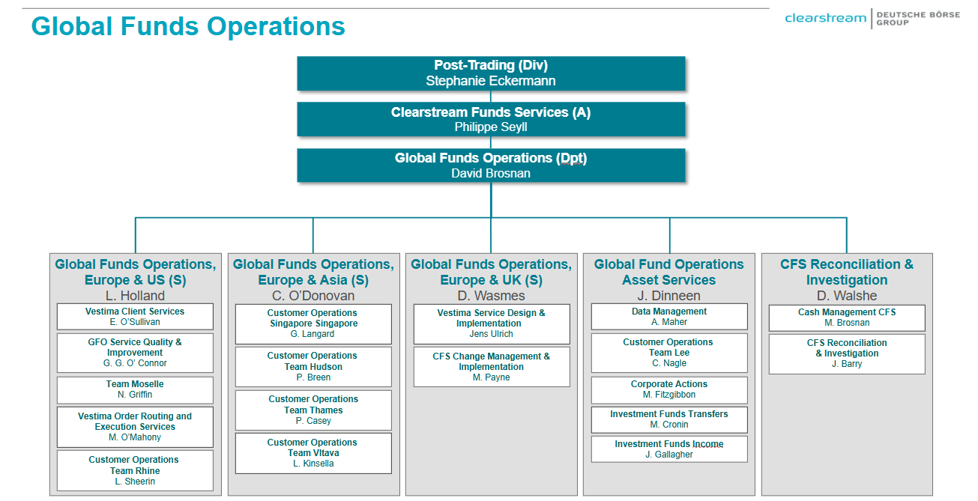
Under the leadership of David Brosnan, GFO is a key operational pillar, and the Dealing element is structured as follows:
- Global Funds Operations Europe & US, led by Lisa Holland, encompasses five units: Vestima Client Services (U), GFO Service Quality and Improvement (U), Team Moselle (U), Vestima Order Routing and Execution Services (U), and Customer Operations Team Rhine (U).
- Global Funds Operations Europe & UK, led by Daniel Wasmes, encompasses two units: Vestima Service Design and Implementation (U) and CFS Change Management & Implementation (U).
- Global Funds Operations Asset Services, headed by John Dineen, includes five units: Data Management (U), Customer Operations Team Lee (U), Corporate Actions (U), Investment Fund Transfers (U), and Investment Funds Income (U).
- CFS Reconciliation & Investigation, led by Des Walshe, oversees two units: Cash Management (U) and CFS Reconciliation & Investigation (U).
- Global Funds Operations Europe & Asia, under Colin O’Donovan, includes four units: Customer Operations Singapore (U), Customer Operations Team Hudson (U), Customer Operations Team Thames (U), and Customer Operations Team Vltava (U).
- Clearstream Australia (CAL) Fund Operations unit headed by Ben Sung also has a functional reporting line to Colin O Donovan. CAL operations deal with Vestima business only and all VestimaPRIME processes on behalf of JP Morgan, their key client, are conducted by Customer Operations Singapore.
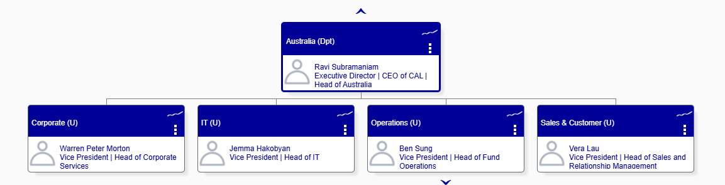
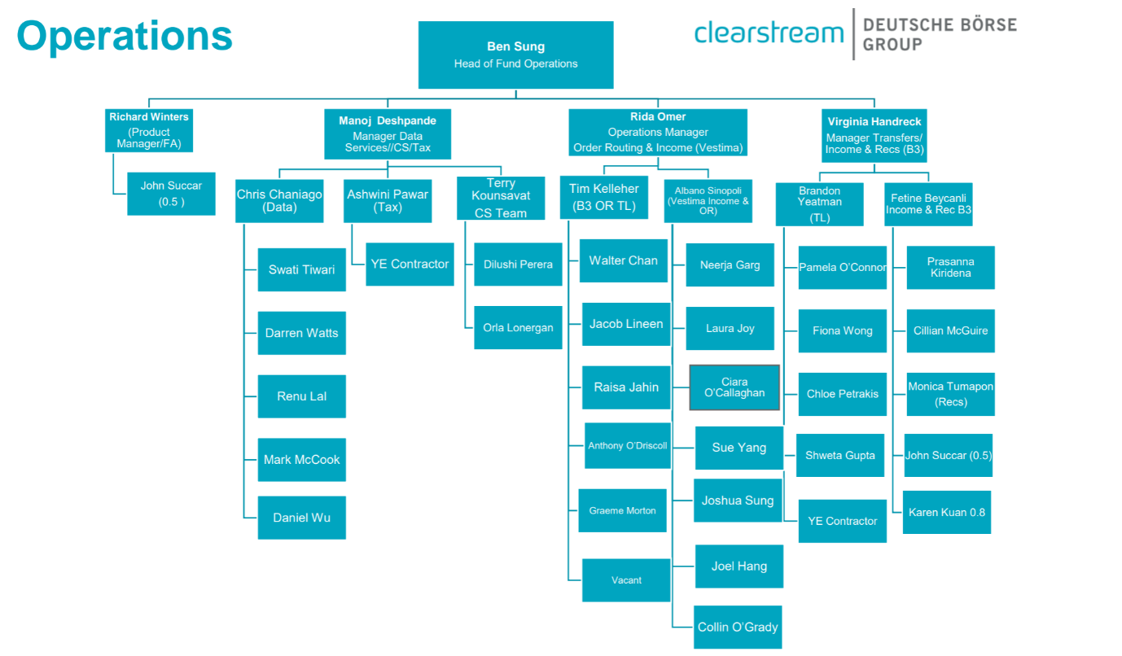
Key changes identified within GFO since the previous audit in 2023 were:
- Substantial increase in GFO Cork's employee count (from 353.8 to 645), driven by higher business volumes and the addition of new functions and business units at the Cork location.
- David Brosnan has assumed additional responsibilities, now overseeing CFS Reconciliation & Investigations (S), Distribution Operations (S), and Kneip Operations (S). All three are not in scope of this audit (separately audited).
- The GFO ExBo reporting line has transitioned from Stephan Leithner to Stephanie Eckermann.
- The Vestima Execution Support and Vestima Order Routing teams have merged into a single unit – Vestima Order Routing and Execution Services – under the leadership of Lisa Holland.
- Customer Operations Team Moselle now reports to Lisa Holland (previously Daniel Wasmes).
- Customer Operations Team Lee now reports to John Dinneen (previously Colin O’Donovan).
- Newly established CFS Change Management & Implementation unit, reporting to Daniel Wasmes.
- Another new unit, Customer Operations Team Hudson, created in 2023 to manage HSBC client services and reports to Colin O’Donovan.
- In 2024 there was a reorganization within CAL – refer to the following hyperlink: CAL Org Structure effective June 2024.pdf

The below unit was deemed low risk after initial review of the documentation provided and, therefore, no further testing will be performed:
- GFO Service Quality & Improvement (U)

The following units were assessed as out of scope for this audit, as previously covered in other ones:
- Corporate Actions (U) – Last covered in 2024 and to be covered again in 2026 as part of the Corporate Actions & Income Processing audit.
- Investment Funds Income (U) – Last covered in 2024 and to be covered again in 2026 as part of the Corporate Actions & Income Processing audit.
- Cash Management CFS (U) – Last covered in 2024 and to be covered again in 2026 as part of the Reconciliation audit.
- CFS Reconciliation & Investigation (U) – Last covered in 2024 and to be covered again in 2026 as part of the Reconciliation audit.
- Vestima Service Design & Implementation (U) was last covered in 2023 and will be covered again as part of the upcoming Customer Onboarding and Maintenance (COM) audit in 2025.

Audit Object L2 actualization
As highlighted in section “1. Annual Audit Planning (AAP) information”, it was noted that the L2’s defined for Order Routing and Execution and for Transfers could be grouped with the respective L2’s covering Vestima and VestimaPRIME workflow, which already encompass order routing and execution and transfers – refer to the grid below for a visual overview:
Current L2’s | New Proposal
AU-025-01-Order routing and execution | - Close AU-025-01 and AU-025-02  - Extend AU-025-07 and AU-025-08 coverage to CS, CBL and CBF.
AU-025-02-Transfers
AU-025-07-Vestima (order routing and execution, transfers)
AU-025-08-Vestima PRIME (order routing and execution, transfers)

CFCL, CBL and CBF HoIA’s approved the proposed changes, and both AAP 2025 Golden Source and Audit Universe were updated accordingly – refer to evidence below:
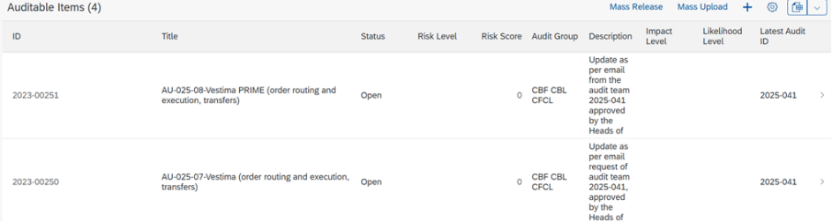

Process based information
The topics for which a comprehensive overview was possible for all the L2’s in scope have been grouped and detailed in the following hyperlinks and documents:
- Relevant & regulatory requirements
- Relevant internal criteria
- IT environment
- Future Notes (FuN’s)
Eight future notes identified as potentially relevant to this audit. Of these, five deemed in scope and three confirmed out of scope. Follow-up will be performed during fieldwork.
- Data from Internal Audit
Twelve findings identified as relevant to this audit, all from the 2023-036 IFS Operations audit (audit report here). However, all recommendations already addressed. Also, no quantitative models identified as applicable to this audit. No follow-up required.
- Data from External Audit
No relevant external findings identified in the FAR tool for either CBL or CBF. CFCL does not use FAR, it maintains a dedicated inventory for monitoring purposes. No relevant external findings identified in this inventory either. No follow-up required.
- Key Business Indicators
Business indicators available via monthly KPI’s reporting and located here. These are monitored and provided separately for each of the following legal entities: CFCL, CFCL Cork, CAL, and CBS. Breaches during the audit scope period: will be tested as part of fieldwork. Also, IA will inquire re. the CBL and CBF KPI’s.
- Outsourcing Framework
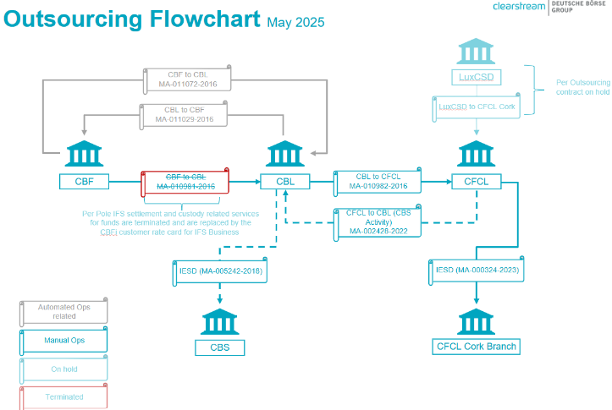
The below outsourcing contracts assessed as non-relevant to this audit:
- CBL to CFCL Cork Branch CO12147 MA-001566-2023 (Claims).
- CFCL to CS CO104447 MA000219-2024 (Treasury Back Office, Treasury Middle Office, Tax Services and Incident Management and other Related Controls).

And the following service providers identified:
- Telekurs and Morning Star for fund acceptance and data management services.
- SAP (C4C) and Genesys (phone system) for customer services and onboarding activities of participants set up.

Internal Audit noted that the contract CBF to CBL MA010981 was terminated and another one, LuxCSD to CFCL Cork, was on hold. A dedicated test will be performed during the fieldwork.
- Available Risk Management data
- Available claims data reviewed and various categories of claims received in 2024 assessed as relevant.
IA leveraged the investigation to determine, among the other criteria applied, the operating effectiveness tests to be conducted during fieldwork.
- Only the CFCL OpRisk scenarios were provided, which aligns with expectations, as CFCL is the sole entity (also considering the Cork Branch and CAL) with own funds-dedicated Operational Risk scenarios. No further testing will be conducted on the generic scenarios, also relevant to CBL and CBF.
- The CFCL KRI’s were analyzed and a threshold breach was identified in Q3 2024 (CFCL-GFO-14 – Number of manual orders). However, this is out of scope as it will be covered as part of Investment Funds Income audit planned for 2026.
- Two URP’s were provided: Clearstream Fund Services / Global Funds Operations / Cork, applicable to CBF, CBL, CFCL, CFCL Cork and LuxCSD and Clearstream Fund Services / Global Funds Operations / Luxembourg, applicable to CBL, CBF and CFCL. Also, all the relevant BIA’s were provided. However, a special audit on General Controls (2025-024) has already been conducted also covering the above topics and, therefore, no dedicated testing will be performed.
- Data from Compliance
- IA reviewed the CFCL 2024 Compliance Control Plan and identified two controls relevant to Global Funds Operations – New fund acceptance framework and Sundry account setup. It was noted that the first control might have been postponed as the document was showing a yellow “P.” A dedicated test was added to the RCA, also proposing an investigation on the CBF and CBL Compliance controls conducted in 2024, which were not received.

Vestima (Order Routing and Execution, Transfers)
Topic | Review and results
Process description | Vestima is Clearstream's automated order routing and execution service for the investment funds industry. It offers a comprehensive suite of services that support the cross-border distribution needs of the global investment fund industry. Vestima provides a gateway to global fund solutions, including order routing, centralized delivery versus payment settlement, safekeeping, asset servicing, and collateral management. It offers a single-entry point and standardized process for all fund transactions, encompassing mutual funds, ETF’s, and Alternative Investment funds.  Order Routing & Execution – Orders from the order issuer (OI) are transmitted through Vestima and are routed in real time. The order handling agents (OHA’s) can receive subscriptions, redemptions and switch orders via Vestima. The OI and OHA do not communicate directly via the Vestima automated system. Integration with the settlement and custody services of Clearstream Banking provides secure straight-through processing (STP) from order input through to final settlement, if required.  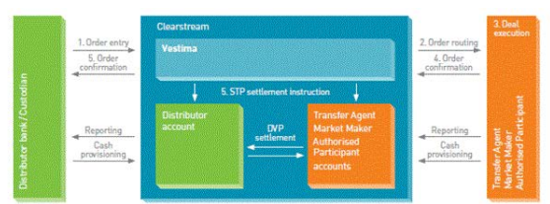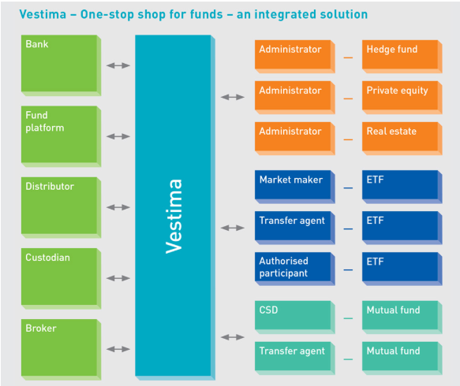  Transfer Services – Vestima Transfer Services handle the transfer of investment funds to and from Clearstream via the register of the transfer agent. This service enables customers to process transfers efficiently using the same preformatted instruction, regardless of the transfer agent. The counterparty can be another Clearstream client (internal transfer), a Euroclear participant (bridge instruction), or an external participant.  Transfer instructions for all types of funds are processed via Vestima (Xact) or SWIFT applications. The application used to check the real-time status in the market is RTS Input. Vestima may also be used to check the status of transfers involving the transfer agent. The specific service within Vestima dedicated to transfers is referred to as “Relocation”.  - Vestima (Xact): Utilized in the transfers process to review transfers instructed via the OHA.  - RTS Input: Internal settlement system used to review settlement instructions.  - Vestima (Relocation): Utilized in the transfers process to check the status of transfers involving transfer agents.
Relevant Organizational structure | The following teams offer clients a one-stop shop solution, covering both Vestima and VestimaPRIME order routing, execution, and transfers:  - Customer Operations Team Lee (U)  - Customer Operations Team Vltava (U)  - Customer Operations Team Rhine (U)  - Customer Operations Team Thames (U)  CAL Investment Funds Operations also deal with Vestima business only.  This integrated service leverages the expertise of 3 additional units:  - Vestima Client Services (U)  - Vestima Order Routing and Execution Services (U)  - Investment Funds Transfers (U)
Conclusion: Risk overview | Based on all information collected, reviewed and analysed for this L2, the below risks, in line with the GRM risk taxonomy, have been identified:  - Business: 06 – Conduct Risk, 016 – Data Integrity Risk, 019-021 – Legal Risk, 025 – Human Error Risk, 028 – Processing and Execution Risk, 032 – In-/Outsourcing and External Procurements Risk and 033 – Third Party Compliance Risk.  - IT: O11 – Cyber Security Risk, O12 – Internal Information Security Risk, O13 – Third Party Information Security Risk, O14 – IT Availability & Continuity Risk and O18 – IT Change Risk.  Conclusions:  - The AID1048 Monarch Automator application will not be tested as it should be allocated to the L2 “121-IT Systems Core Services (CBF, CBL)” – “CSDR Core Systems (CBF, CBL)” audit.  - Both design and operating effectiveness tests will be conducted on this L2.  - DA will be implemented as testing support, where possible.
Data Analytics | Based on the preliminary assessment conducted, IA concluded that this process is eligible for DA testing. This means that structured data is available, and relevant tests can be anticipated. The specific application and scope of DA will be further evaluated during the fieldwork phase. At that stage, IA will determine how DA can best support the audit procedures. The approach taken, along with the conclusions drawn, will be thoroughly documented in the working papers and summarized in the final Audit Conclusions.
Defined test | Refer to the RCA.

5.2. VestimaPRIME (order routing and execution, transfers)
Topic | Review and results
Process description | VestimaPRIME serves as the central platform for executing orders in hedge and alternative investment funds, developed in response to growing market volatility, increasing regulatory demands, and the lack of standardization in order placement and settlement processes. As a secure, web-based interface, VestimaPRIME offers users a single point of access to their alternative fund accounts, with encrypted entry enabled through electronic certificates issued by Clearstream.  Order Routing & Execution – The platform supports order routing for subscriptions, redemptions, and switches, directing them to the appropriate Transfer Agents. Orders can be submitted via SWIFT or directly through the VestimaPRIME portal. Clients are notified in advance of cash due dates for subscriptions and expected settlement dates for redemptions, in accordance with fund rules or Transfer Agent requirements. The Global Fund Operations (GFO) team ensures that all necessary documentation is completed based on client declarations and provided to Transfer Agents as needed.  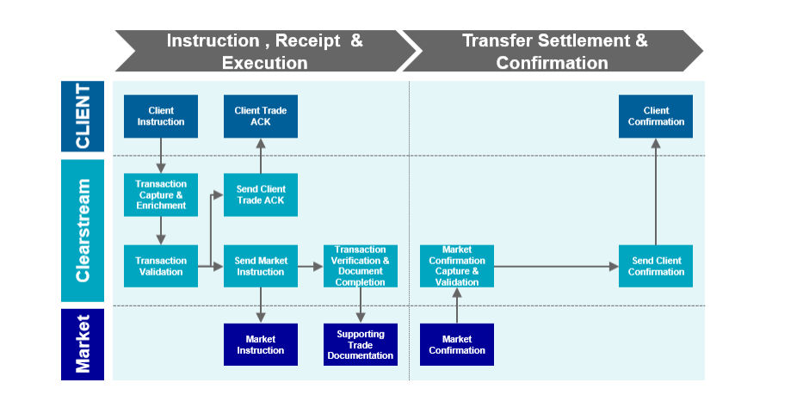  In addition to VestimaPRIME, Clearstream utilizes several other key systems to support its operations. Albert, the IFS digitization platform, is designed to handle semi-structured data such as email attachments, orchestrating workflows and integrating with internal systems to streamline processes and allow staff to focus on client-facing tasks. Meanwhile, CCS (Clearstream Custody System) acts as the core infrastructure, managing order entries via CFN and SWIFT, facilitating market placements, custody processing, and settlements.  Transfer Services – Transfers within VestimaPRIME involve the movement of securities between accounts without any associated cash flow. These transfers are initiated by Clearstream and coordinated with the relevant Transfer Agents, including the submission of required documentation. The process encompasses order processing, status tracking, mailbox monitoring for client and agent queries, contract note follow-up, and final confirmations to clients upon completion.
Relevant Organizational structure | The following customer operations teams offer a one-stop shop solution for clients, covering both Vestima and VestimaPRIME order routing, order execution, and transfers:  - Customer Operations Team Lee (U)  - Customer Operations Team Vltava (U)  - Customer Operations Team Rhine (U)  - Customer Operations Team Thames (U)  - Customer Operations Team Moselle (U)  - Customer Operations Team Hudson (U)
Conclusion: risk overview | Based on all information collected, reviewed and analysed for this L2, the below risks, in line with the GRM risk taxonomy, have been identified:  - Business: 06 – Conduct Risk, 016 – Data Integrity Risk, 019-021 – Legal Risk, 025 – Human Error Risk, 028 – Processing and Execution Risk, 032 – In-/Outsourcing and External Procurements Risk and 033 – Third Party Compliance Risk.  - IT: O11 – Cyber Security Risk, O12 – Internal Information Security Risk, O13 – Third Party Information Security Risk, O14 – IT Availability & Continuity Risk and O18 – IT Change Risk.  Conclusions:  - SP_CFCL_CO_1.2.3.2_CSDR Sec. Recon. process will remain out of scope as it falls under the Share Reconciliations process, which will be encompassed in the 2026 Reconciliations audit.  - Both design and operating effectiveness tests will be conducted on this L2.  - DA will be implemented as testing support, where possible.
Data Analytics | Based on the preliminary assessment conducted, IA concluded that this process is eligible for DA testing. This means that structured data is available, and relevant tests can be anticipated. The specific application and scope of DA will be further evaluated during the fieldwork phase. At that stage, IA will determine how DA can best support the audit procedures. The approach taken, along with the conclusions drawn, will be thoroughly documented in the working papers and summarized in the final Audit Conclusions.
Defined test | Refer to the RCA.

5.3. Fund acceptance and data management
Topic | Review and results
Process description | The Fund Acceptance team is part of the Data Management unit and is within the Asset Services section carrying out all operational activities of GFO. Main activities carried out by Fund Acceptance are:  - Issuance of LU ISIN codes for investment funds  - Acceptance of mutual and hedge funds from LU and other supported jurisdictions within Clearstream  - Associated tasks, i.e., Reference Data Maintenance  Fund Acceptance within IFS is split across two locations. Fund Acceptance is mainly taking care of the issuance of LU ISIN codes and the acceptance of mutual funds on Vestima (our automated order routing platform) but also the setup of hedge funds on VestimaPRIME.  The Data Management unit, instead, is responsible for:  - Handling the acceptance of hedge funds on CFN/VestimaPrime (hedge fund platform)  - Setup of new funds and fund agents in CCS  - Setup of new funds and fund agents in RDF (Non-CSD, client Teams)  - Maintenance of static fund information on CCS  - Maintenance of static fund agent information on CCS  - Customer Query Handling  - Analysis and acceptance of client portfolio during onboarding phase, Vestima/Creation and CFN/CCS  - Trading Chain (agent code) maintenance (Vestima)  - TA changes & related maintenance  - Compliance checks funds and fund agents  - Payment detail - Audit
Relevant Organizational structure | Both the fund acceptance and data management processes fall under the responsibility of Andrew Maher, head of Data Management (U). This unit reports directly to John Dinneen, head of Global Funds Operations Asset Services (S).  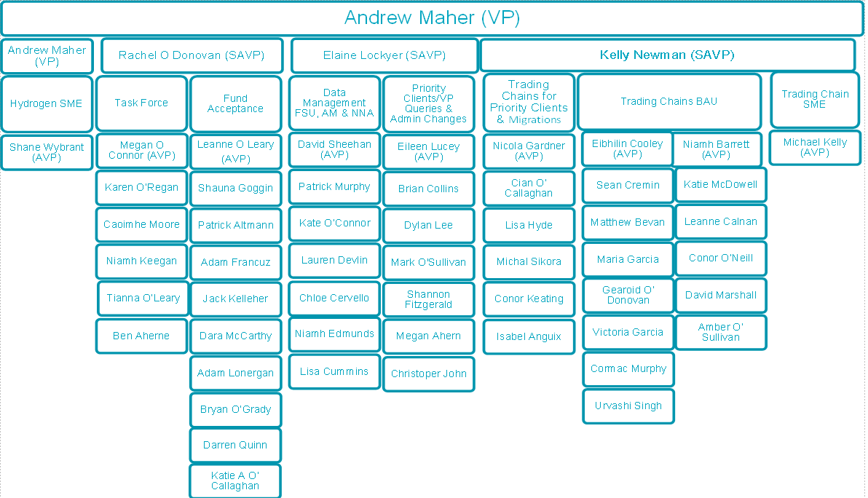
Conclusion: Risk overview | Based on all information collected, review and analysed for this L2, the below risks, in line with the GRM risk taxonomy, have been identified:  - Business: 06 – Conduct Risk, 016 – Data Integrity Risk, 019-021 – Legal Risk, 025 – Human Error Risk, 028 – Processing and Execution Risk, 032 – In-/Outsourcing and External Procurements Risk and 033 – Third Party Compliance Risk.  - IT: O11 – Cyber Security Risk, O12 – Internal Information Security Risk, O13 – Third Party Information Security Risk, O14 – IT Availability & Continuity Risk and O18 – IT Change Risk.  Conclusions:  - Both design and operating effectiveness tests will be conducted on this L2.  - DA will be implemented as testing support, where possible.
Data Analytics | Based on the preliminary assessment conducted, IA concluded that this process is eligible for DA testing. This means that structured data is available, and relevant tests can be anticipated. The specific application and scope of DA will be further evaluated during the fieldwork phase. At that stage, IA will determine how DA can best support the audit procedures. The approach taken, along with the conclusions drawn, will be thoroughly documented in the working papers and summarized in the final Audit Conclusions.
Defined test | Refer to the RCA.

5.4. Customer services
Topic | Review and results
Process description | The Vestima and VestimaPRIME Customer Services units serve as the primary points of contact for Order Issuers and Order Handling Agents. They facilitate centralized communication between both parties, while ensuring that information is only shared when necessary and with mutual agreement.  All queries related to Vestima, and its supporting operations are managed through a centralized mailbox and incoming calls. Additionally, dedicated email inboxes are maintained for high-priority clients to ensure prompt and tailored support.  VestimaPRIME-related queries are handled by the Customer Operations team, which is responsible for end-to-end client servicing. These queries are received via dedicated email inboxes or through direct phone calls, ensuring efficient and responsive communication.  In addition, services offered to customers include but are not limited to:  - Support to customers using Vestima and VestimaPRIME platforms  - Investigation and replacement of rejected orders  - Query handling for operational functions, including queries on transfers, corporate actions, cash, and static data  - Support on exceptional trading  - Regular and ad-hoc service calls
Relevant Organizational structure | Vestima Customer Service is under the responsibility of Eimear O'Sullivan, head of Vestima Client Services (U). The team is responsible for all Vestima-related customer service queries.  In addition, customer service for high-priority Vestima clients is managed within the relevant Customer Operations teams, which is responsible for handling both Vestima and VestimaPRIME service queries for designated clients:  - Customer Operations Team Lee - One Stop Shop for Lombard Odier  - Customer Operations Team Vltava - One Stop Shop for UBS  - Customer Operations Team Rhine (U) – One Stop Shop for Bank Julius Baer and JP Morgan EMEA  - Customer Operations Team Thames (U) – One Stop Shop for Vestima Asia’s clients outside of business hours of Customer Operations Singapore  All VestimaPRIME customer service queries are again managed by the relevant Customer Operations teams, which is responsible for providing dedicated support to the relevant clients.  - Customer Operations Team Lee (U)  - Customer Operations Team Vltava (U)  - Customer Operations Team Rhine (U)  - Customer Operations Team Thames (U)  - Customer Operations Team Moselle (U)  - Customer Operations Team Hudson (U)  - Customer Operations Singapore (U)
Conclusion: Risk overview | Based on all information collected, review and analysed for this L2, the below risks, in line with the GRM risk taxonomy, have been identified:  - Business: 06 – Conduct Risk, 016 – Data Integrity Risk, 019-021 – Legal Risk, 025 – Human Error Risk, 028 – Processing and Execution Risk, 032 – In-/Outsourcing and External Procurements Risk and 033 – Third Party Compliance Risk.  - IT: O11 – Cyber Security Risk, O12 – Internal Information Security Risk, O13 – Third Party Information Security Risk, O14 – IT Availability & Continuity Risk and O18 – IT Change Risk.  Conclusions:  - Both design and operating effectiveness tests will be conducted on this L2.  - DA will be implemented as testing support, where possible.
Data Analytics | Based on the preliminary assessment conducted, IA concluded that this process is eligible for DA testing. This means that structured data is available, and relevant tests can be anticipated. The specific application and scope of DA will be further evaluated during the fieldwork phase. At that stage, IA will determine how DA can best support the audit procedures. The approach taken, along with the conclusions drawn, will be thoroughly documented in the working papers and summarized in the final Audit Conclusions.
Defined test | Refer to the RCA.

Outcome of the initiation panel
The initiation panel was held on Wednesday, 28 May 2025. During the discussion the following topics were discussed:
- The UNO (Unified for New Opportunities) project aims to transition Clearstream Banking Frankfurt to core CSD services and return CBF’s banking license. This involves closing all CBFi accounts and migrating assets to CBFd, CBL, or CFCL accounts, making underlying securities T2S-eligible. The project intends to streamline operations and reduce regulatory complexity.

The planned changes will be implemented per market in multiple migration waves. Market migration will begin in Q4 2025 with pilot markets, continue throughout 2026, and conclude with the closure of all CBFi accounts by Q1 2027.
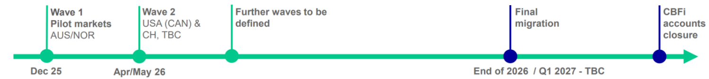

IA will inquire about the project, as requested by the heads, particularly focusing on the impact on the funds business.

- DA testing will be implemented during the fieldwork, where possible.

- The onboarding activities of participants set up process will be assessed during the COM audit later on this year. In addition, and as part of the audit conclusions, the possibility of splitting the L2 process Customer Services and Client Onboarding of Participants set-up into two separate L2 processes will be assessed, as these two activities are not strictly related.

Link to 2023-036 IFS Operations (CBF, CBL, CFCL) audit in SharePoint.
IA obtained permission to proceed with the audit as planned, as the noted misalignment had no impact given the 2Y audit frequency and the Strong/Robust CMI. Based on the outcomes and conclusions of this audit, it will be determined whether an update to the AAP 2025 Golden Source is needed, or if the “medium” risk assessment remains appropriate.
IA obtained permission to close AU-025-01 and AU-025-02 and extend AU-025-07 and AU-025-08 coverage to CS, CBL and CBF – refer to section “4. Audit Object L2 actualization”.
After investigation, IA concluded that LuxCSD has been “excluded” from this audit scope due to a lack of customer uptake for the fund services. As a result, Product Management has discontinued offering these services. This information was confirmed by Helene Houssa from IFS Product Management.
To facilitate the launch of a minimum viable product (MVP), the system was initially deployed with a limited set of functionalities and interfaces. Operational gaps were temporarily addressed through manual workarounds. However, due to the relatively low transaction volume during the audit scope period, the impact of these limitations was minimal. IA is aware that a new system update is scheduled for release in June 2025, which is expected to introduce enhanced automation and added functionalities. In light of this upcoming release, IA determined that a comprehensive review of the current FCBS-related operational processes would add limited value. IA’s focus will instead be on change management and testing relating to the June 2025 release.
While not explicitly stated in the RCA, some of these key changes may be subject to inquiry during the design effectiveness testing phase (walkthroughs).
No further testing on the relevant and regulatory requirements will be performed.
Relevant internal policies and procedures will be checked during the fieldwork – refer to the RCA.
No further testing on IDP’s will be performed. Relevant IT general controls tests are available in the RCA.
UNO Steering Committee – April 25th, 2025 - UNO SteerCo April 2025 - 20250425 v1.0.pptx.

